**Assignment 1**

* How to take a backup of your instance and launch new instance from the Backup.

Synopsis:

Demonstrate how to take a backup of your instance and Launch Brand New instance from your backup with the same configuration.

**Solution:**

1)First, we need an instance to take a backup and stop that existing instance.

2) After stopping the instance, we need to go to actions dropdown button to take a backup and there we should create an image.

3) Under AMIs section the backup of the server has created.

4) Then launch the instance from the backup instance we have created.

4) Finally, launched the new instance from backup with the same configurations.

* Using EBS with EC2 Linux Server Instances.

Synopsis:

Demonstrate the creation, attaching, accessing, and updating of an additional Elastic Block Store (EBS) across EC2 Linux Servers in the same Subnet as well as in the subnets (of a user created Virtual Private Network (VPC)) created in different Availability Zones (AZs) of the region!

**Solution:**

1. First, we must create a VPC and subnets for different availability Zones in the same region.

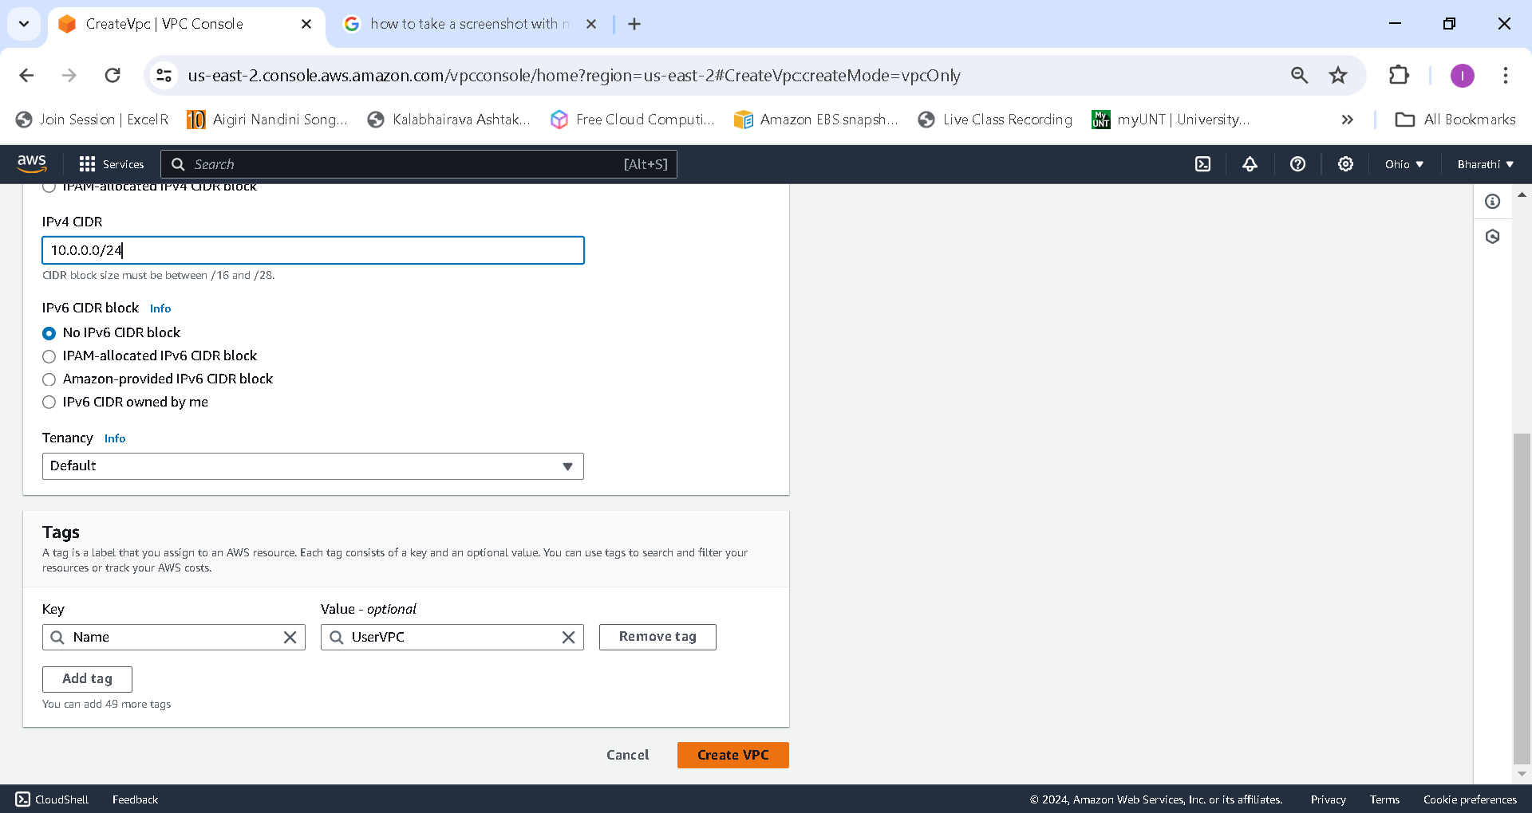

1. Created subnets under userVPC in three different Availability Zones.

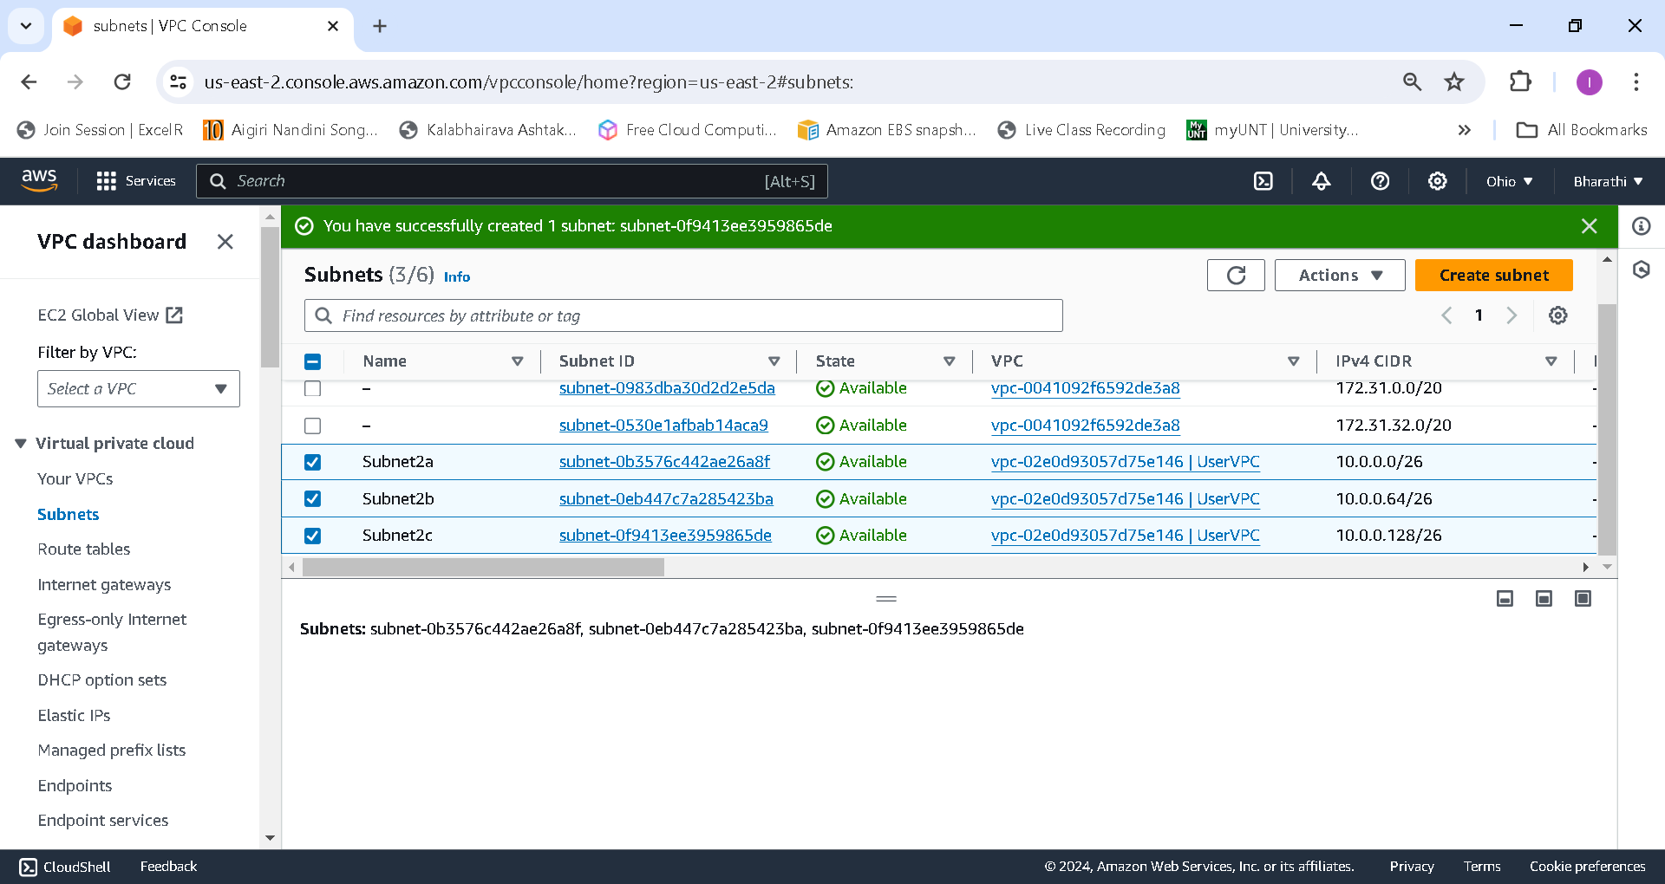

1. Created two different Linux servers under different subnets and availability zones within the same user created VPC.

1. Created two 5gb EBS volumes in different availability zones.

1. Need to attach the EBS volumes to the respective servers under the same availability zone.

1. Connect the Ec2 instance and using lsblk command we can identify available unmounted volume xvdb

1. To mount the the Volume, we must create a folder and file system by using the following commands.

i) mkdir /dir1(folder name or directory).

ii) mkfs -t ext4 /dev/xvdb(unmounted volume).

iii) Then, after creating directory and file system, we are ready to mount the volume to the respective folder and file system which we have created before by using following command. mount /dev/xvdb /dir1/

iv) To check the mounted volume, we have the command df -Th.

1. We should do the same process for another server under different availability zone and subnet.

Assignment 2

* Migrate your instance from One Region to Another Region

Synopsis:

I want to move or copy my Amazon Elastic Compute Cloud (Amazon EC2) instance to another subnet, Availability Zone, or virtual private cloud (VPC).

Use the two methods for migrating the instance:

1.Use the AWS Systems Manager automation document AWSSupport-CopyEC2Instance.

2.Manually copy an instance and a launch a new instance from the copy.

Solution by using AWS Systems Manager automation document.

1. First we need to create an EC2 instance in one region.

1. Navigate to AWS system manager and select automation option.

1. Then, select Execute automation and search for the AWSSupport-CopyEC2Instance document.

1. Select the instance you want to move and give the region name in the parameter section and then execute the automation.

1. After successfully executed all steps we can see an instance created in our destination region(us-west-2)

Solution by manual method

1. First, we need to create an image from source region which is Ohio.

1. Then copy the AMI from source region and provide the destination region you want to move to.

1. Go to destination region and open the AMI section and then launch the instance from the AMI copied from the source region.

Assignment 3

* Host and deploy an application using Elastic Beanstalk

Synopsis:

Create your example application, you'll use the Create a web app console wizard. It creates an Elastic Beanstalk application and launches an environment within it. An environment is the collection of AWS resources required to run your application code.

1. Navigate to Amazon elastic beanstalk window and click on create application and complete all the configuration steps involved.

1. Select the webserver environment and give you application name and select the platform(PHP).

1. Select the instance type and service role and setup the database and networking if needed, here not creating any database because it’s a sample application.

1. Setup the autoscaling and load balancing according to the requirement.

1. Submit after finishing all the 5 steps.

1. Finally, environment successfully launched, and as the health is green.

1. Sample application has been deployed successfully.

